- These don’t look (vertically) aligned.Done
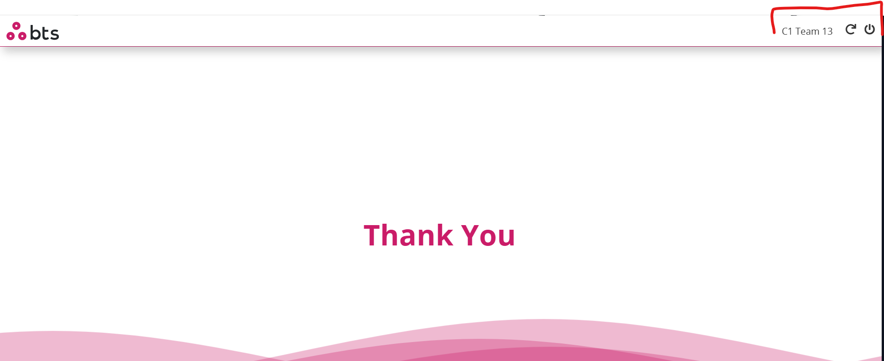

Reset takes me to this screen, and there is a weird line there. Done
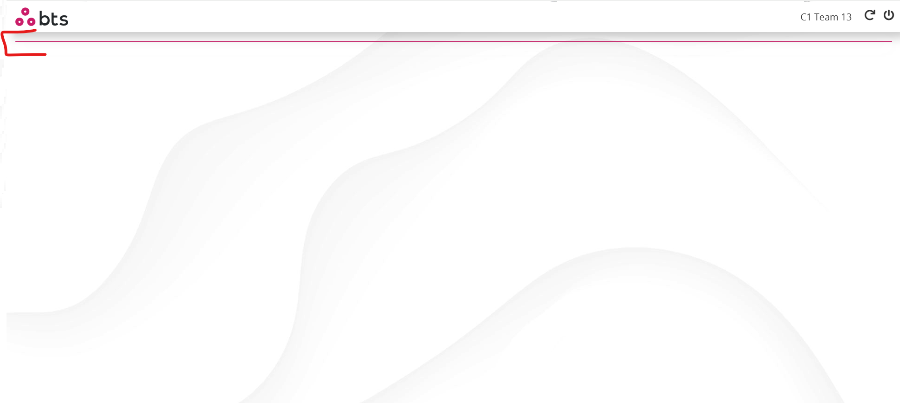

Let’s remove this. Done
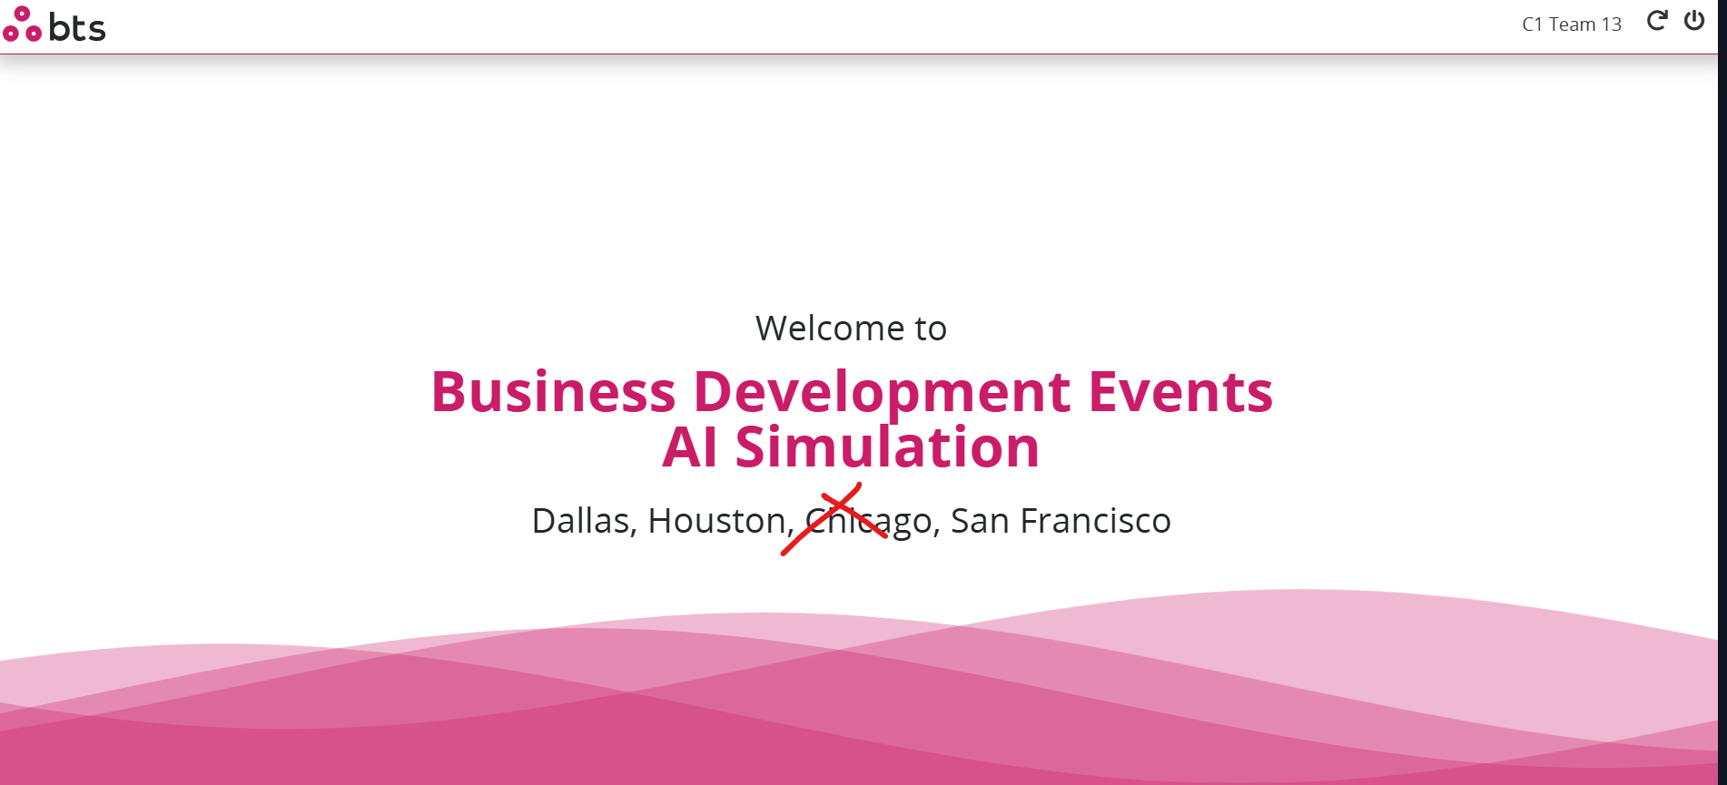

Please fix team name screen for F login. Done

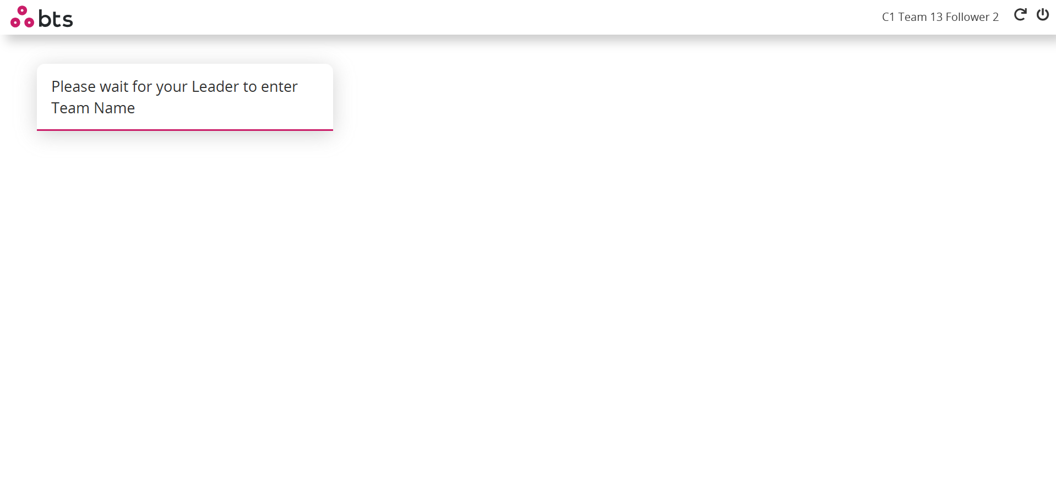

- Is this faded effect intentional?Done
- Team Name screen is not accepting hyphens. Done
- I understand the sim is BTS branded, but we could have still avoided these wave effect and used something else. Done
All bigshots (including Jessica Skon) is going to be part of these deliveries. Let’s put in a little more effort to make it look better.

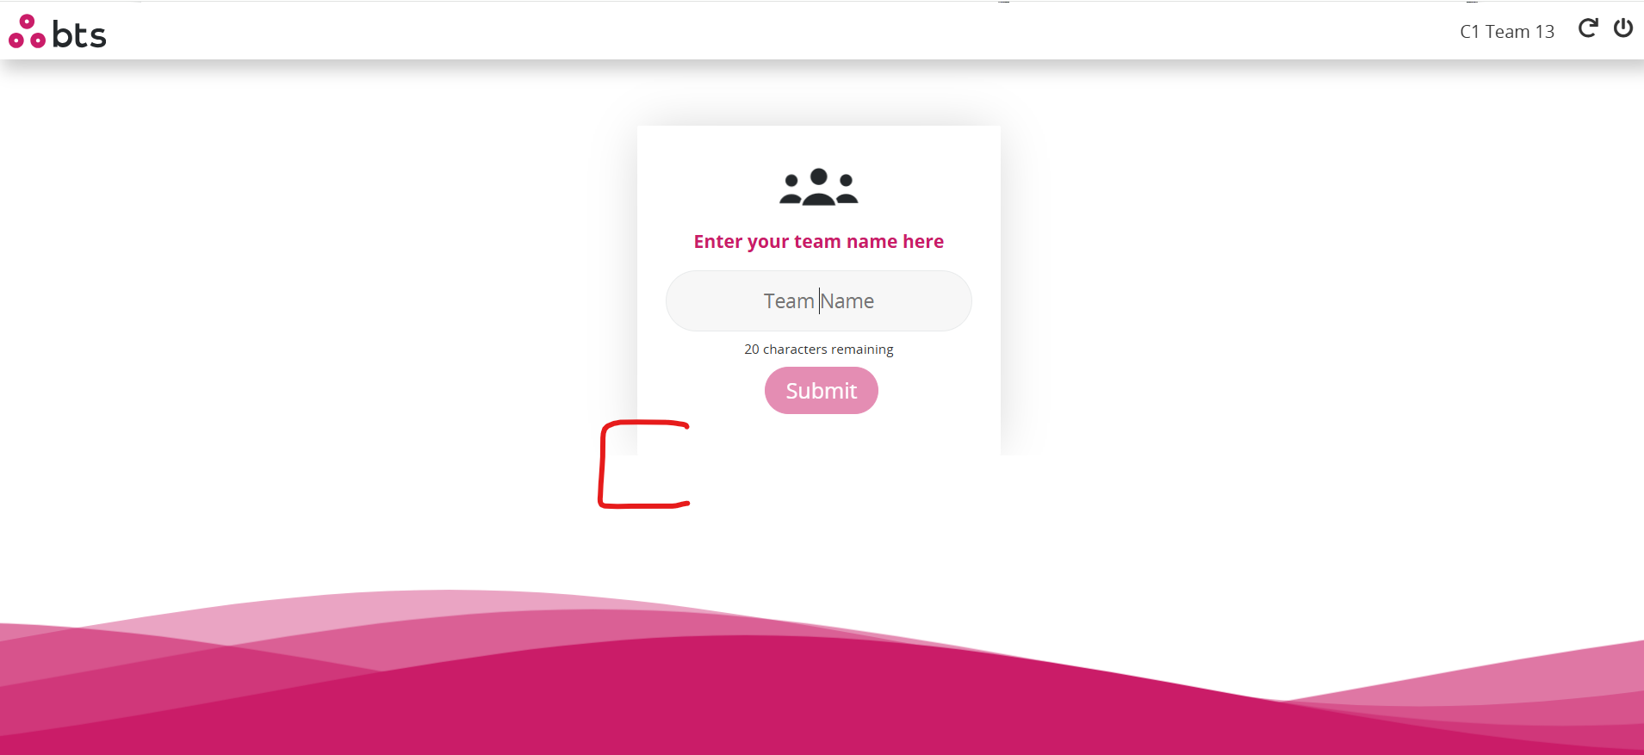

Again faded effect in the bottom does not look very appealing. Done
The screen looks too bland. Done

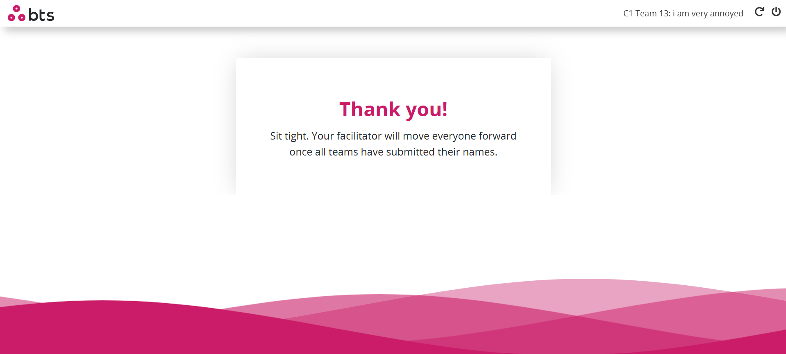

- Please change the images at least!
- There is no differentiation between the header and the main content area. Done

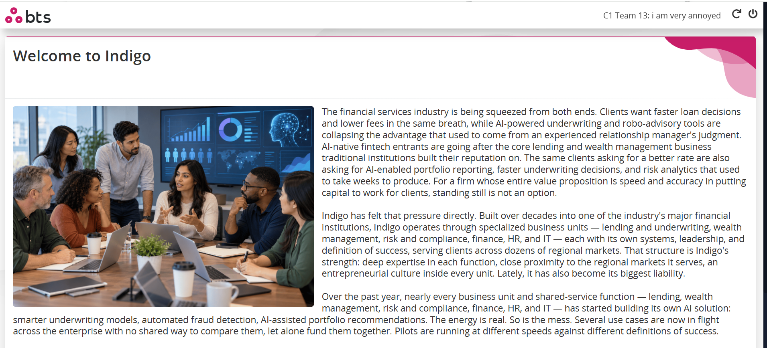

Font colour of F login is too light. Done
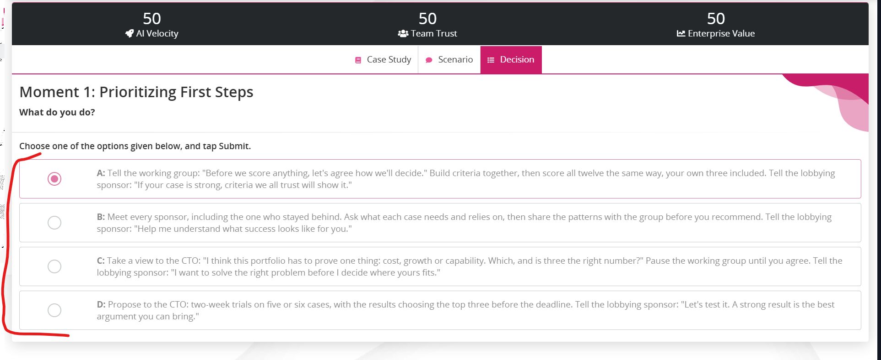

Please fix this. Done
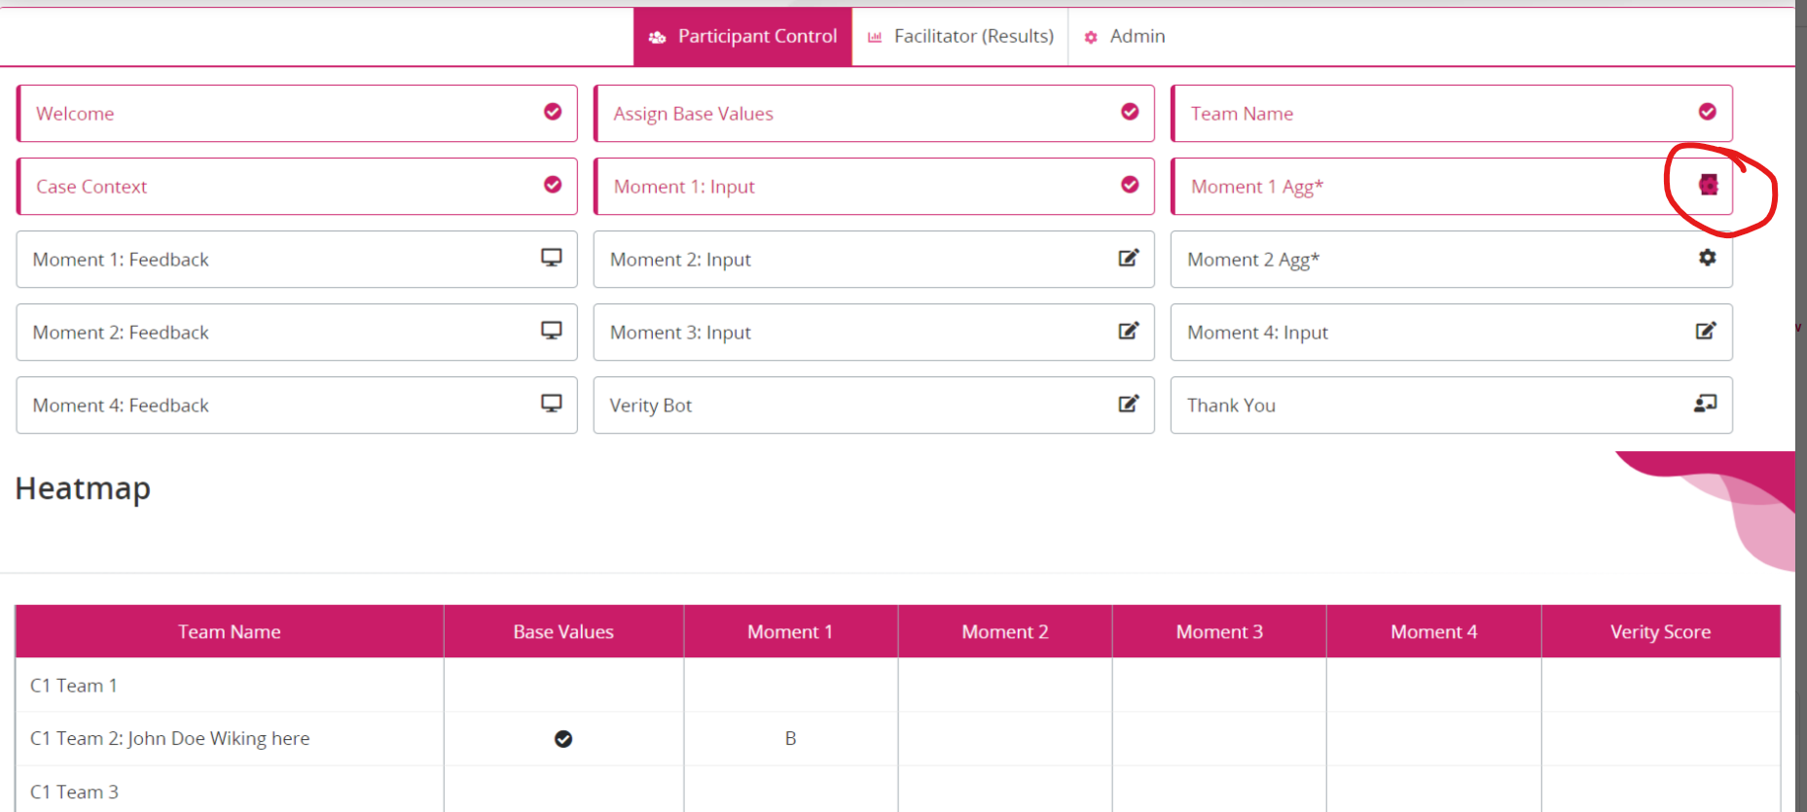

- The grey bar looks merged. Is that intentional? Yes its as per design
- Numbers are too small to read. Done
- Numbers have been pushed too much in the corner. Done
They could be centrally aligned within the column.
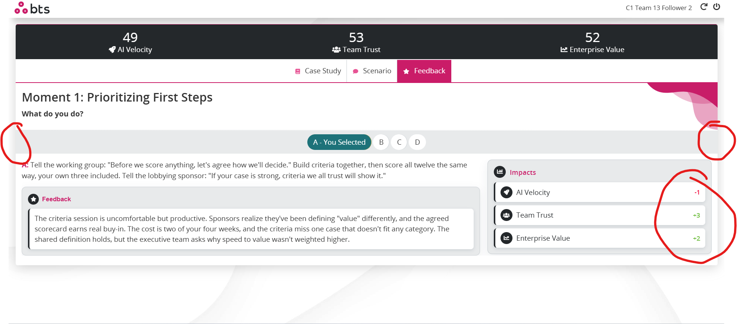

- Please make 0 in black font. Done

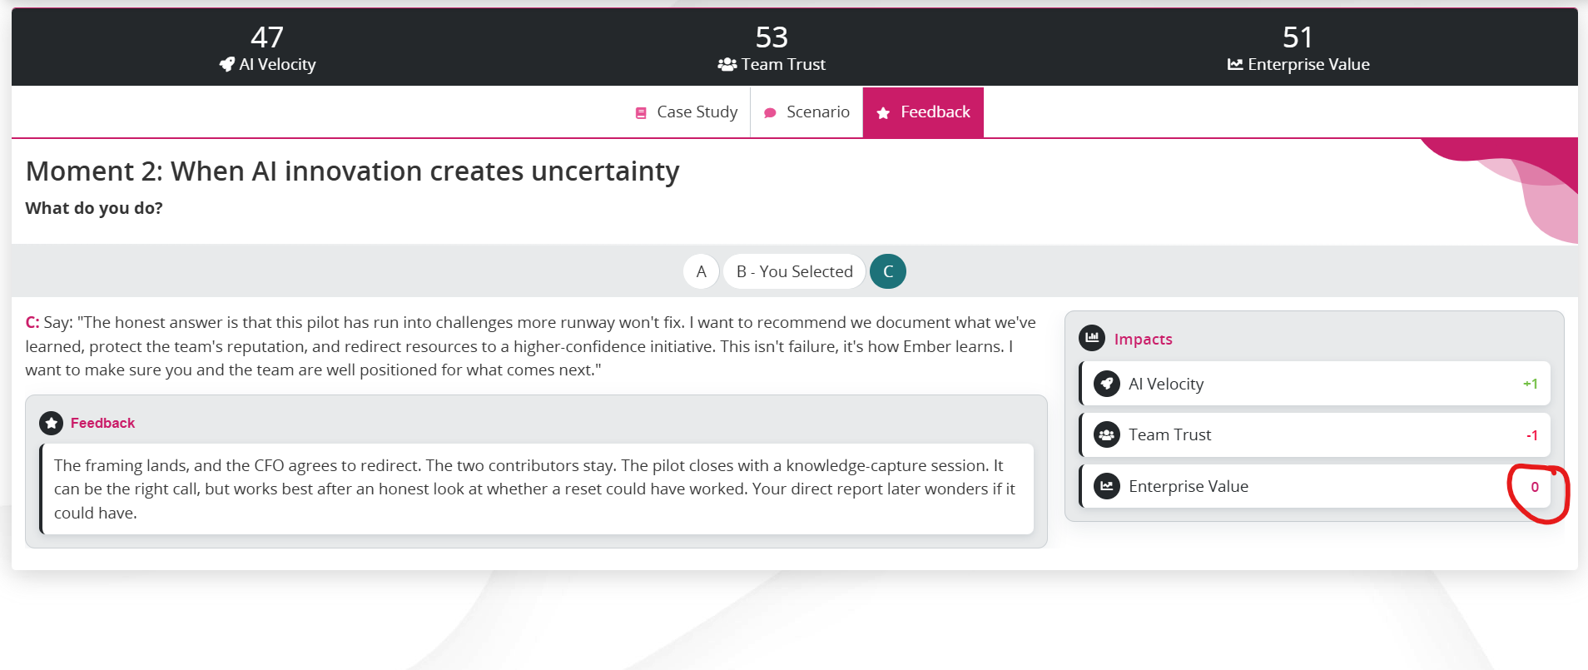

- Reduce this white space as much as we can.
- Placeholder text can simply be “Enter text here.” Done
- Also, since it is multiple entries, we should add it as a separate tab. Done
- Show live data of only my team below. Done
- If possible, show entries on F login as well. Done
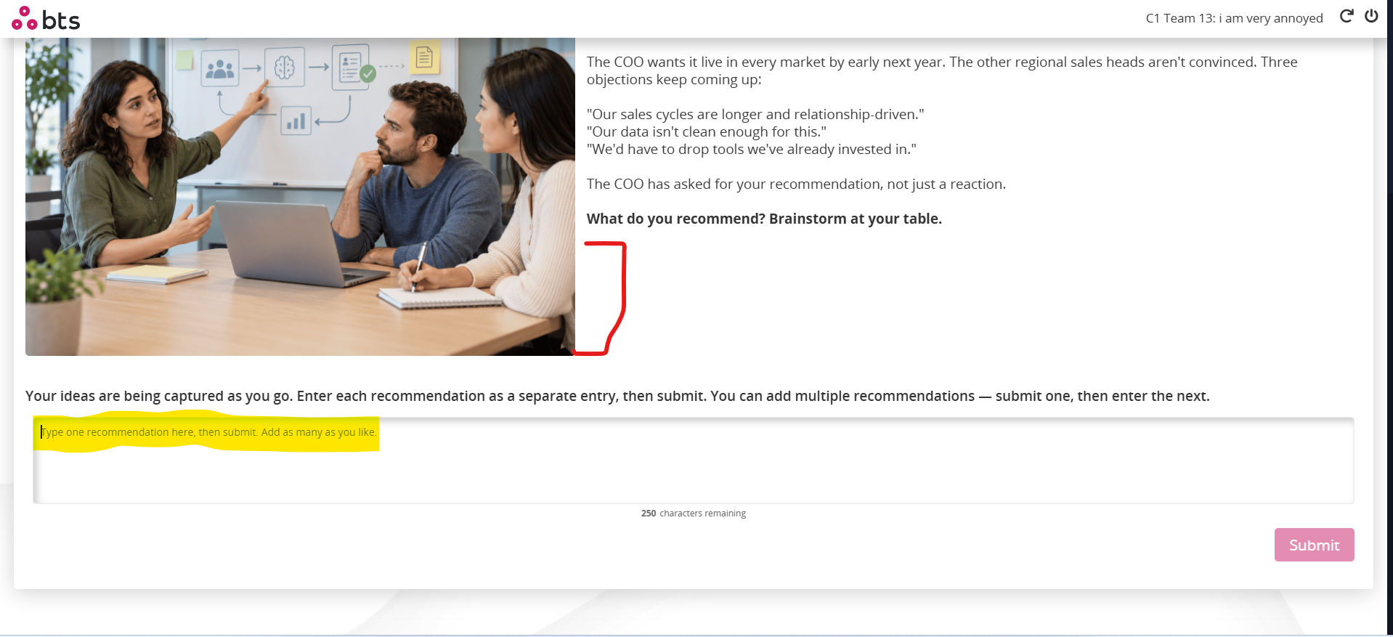

- Give some space between text and bot area. Done
- Borders are inconsistent. Done
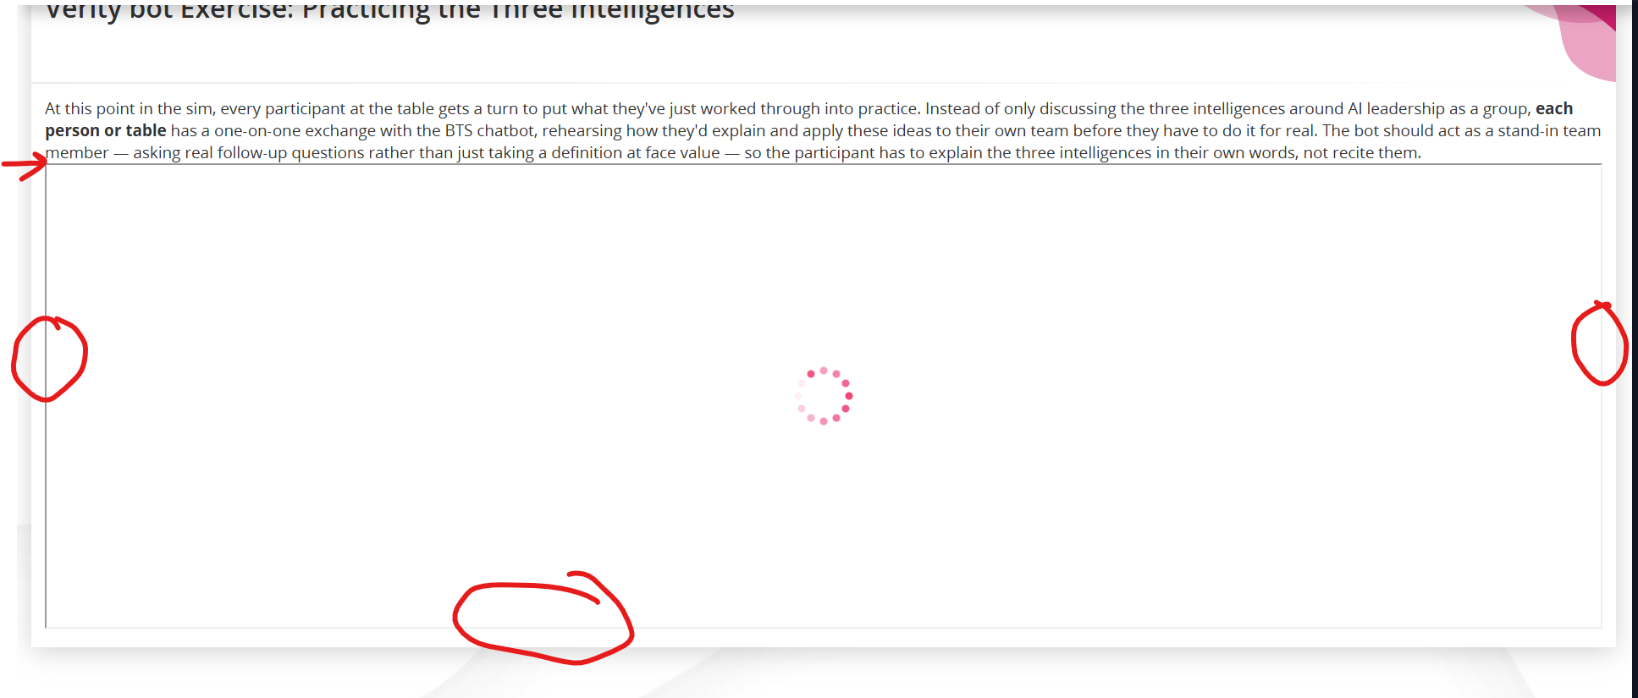

This should be underlined as well. Done

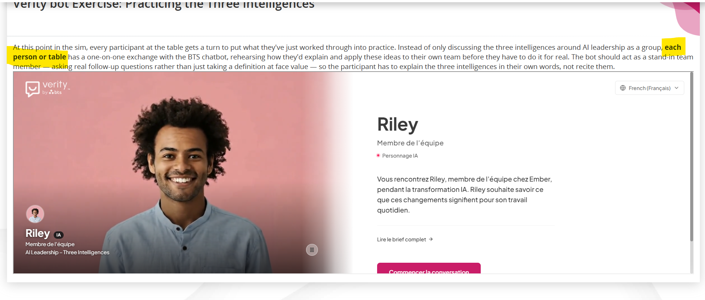

Fix F login. Done
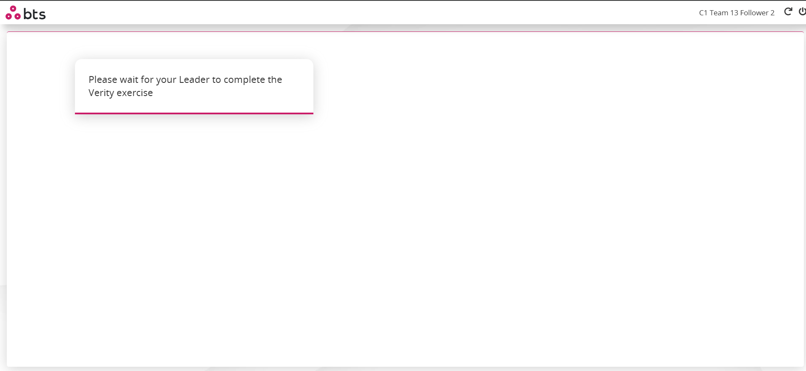

Add textlist results as well for BS. Done

These overlap on hover. Done

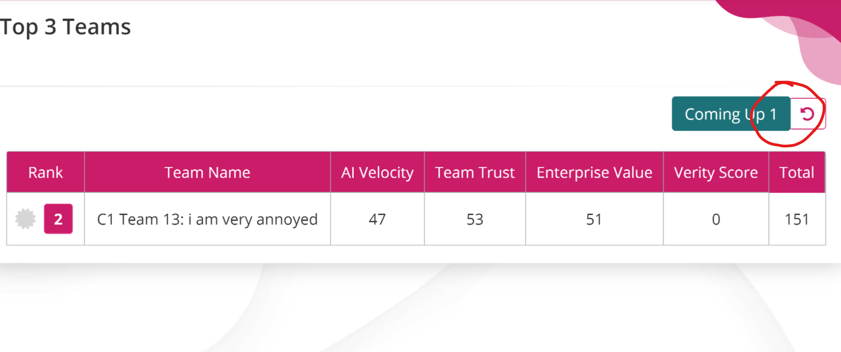

Can we fix column widths? Done

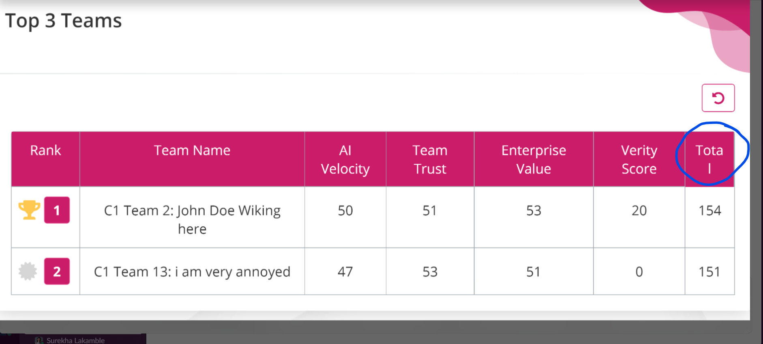

- Centrally align numbers in reporter login. Done
- Is there an extra line/border around the table header? Done

